**VISVESVARAYA TECHNOLOGICAL UNIVERSITY**

**“JNANA SANGAMA” BELAGAUM – 590 018**

  
 **A MINI PROJECT REPORT**

On

**SECURITY ALARM SYSTEM USING PIR SENSOR**

***Submitted in partial fulfillment for the award of the degree of***

***Bachelor of Engineering***

**In**

**ELECTRONICS AND COMMUNICATION ENGINEERING**

**Academic year 2020 – 2021**

**By**

|  |  |
| --- | --- |
| **B V Tharani** | **1GD18EC010** |
| **Shushmitha P S** | **1GD18EC039** |
| **Varalakshmi G** | **1GD18EC043** |



**GOPALAN COLLEGE OF ENGINEERING AND MANAGEMENT**

**DEPARTMENT OF ELECTRONICS AND COMMUNICATION ENGINEERING**

**BANGALORE-560048**

**GOPALAN COLLEGE OF ENGINEERRING AND MANAGEMENT**

**(Accredited by NAAC, 2(f) status by UGC & ISO 9001:2015)**

**Approved by All India Council for Technical Education (AICTE), New Delhi**

**Affiliated to Visvesvaraya Technological University (VTU), Belagavi, Karnataka**

**Recognized by Govt. of Karnataka**

**Department of Electronics & Communication Engineering**



**CERTIFICATE**

This is to certify that the mini-project report entitled “SECURITY ALARM USING PIR SENSOR” is a bonafide work carried out by B V Tharani(1GD18EC010), Shushmitha P S (1GD18EC039), Varalakshmi G(1GD18EC043), in partial fulfilment for the award of the degree of Bachelor of Engineering in Electronics and Communication Engineering of Visvesvaraya Technological University, Belgaum during the year, 2020-2021. The mini-project report has been approved as it satisfies the academic requirement with respect to seminar work prescribed for the said degree.

Signature of the HOD

**Dr. Anantha Padmanabhan**

**ACKNOWLEDGEMENT**

The mini-project report was the result of the encouragement of many people who helped in shaping it and provided feedback, direction and valuable support. It is with hearty gratitude that I acknowledge their contribution.

I take this opportunity to express my deep sense of gratitude to the principle, **Dr. N.** **SENGOTTAIYAN** and the esteemed institution Gopalan College of Engineering and Management, for providing us all the resources to carry out this project work.

I am highly grateful to **Dr. Anantha Padmanabhan,** Professor and HOD of ECE, GCEM, Bangalore, for kind support, guidance and encouragement throughout the course of this project work.

I would also like to thank all the **Teaching** and **Non-Teaching staff** of Dept. of ECE for their kind co-operation during the course of this project work. The support provided by the college and departmental library is gratefully acknowledged.

Last but not the least, heartful thanks to our **Parents** and **Friends** for their support.

**B V Tharani(1GD18EC010)**

**Shushmitha P S(1GD18EC039)**

**Varalakshmi(1GD18EC043)**

**ABSTRACT**

In this project passive infrared sensor “PIR” based security system is introduced. With this sensor we can save power, and effective management at low cost and requires small memory space. The PIR sensor is responsible for detecting the change in infrared radiation levels when an intruder or human is passed through the system or space where it is arranged. Depending on the change in radiation levels the change in voltages occurs and then with this voltage the signal is amplified and hence the sound will be produced. Thus, it is helpful in various applications and areas. This type of system has many advantages compared to the existing system.

Contents

**TOPIC**  **PAGE NO**

**Chapter 1:**

INTRODUCTION 1

**Chapter 2:**

COMPONENTS USED 2

**Chapter 3:**

ARCHITECTURE OF PIR SENSOR 3

**Chapter 4:**

WORKING OF PIR SENSOR 5

**Chapter 5:**

METHODOLOGY 6

**Chapter 6:**

CIRCUIT DIAGRAM 7

**Chapter 7:**

WORKING OF THE CIRCUIT 8

**Chapter 8:**

TEST RESULTS 9

**Chapter 9:**

WAVEFORM 9

**Chapter 10:**

ADVANTAGES 10

**Chapter 11:**

DISADVANTAGES 10

**Chapter 12:**

APPLICATIONS 11

**Chapter 13:**

FUTURE SCOPE 12

**Chapter 14:**

CONCLUSION 12

**Chapter 15:**

FLOW CHART 13

# INTRODUCTION

Due to increasing number of crimes and burglary, the need of security system is very essential. The security system that monitors the area throughout the time and reacts effective to the treat is in need. We have lots of security systems in the market for both indoor and outdoor applications such as ultrasonic detectors, CCTV, microwave detectors, photoelectric detectors, etc., However one or the other systems have limitations of being expensive, more electrical power consumption and complex circuitry, etc.

A solution to overcome these problems could be by using a sensor of low cost which has the ability to detect the intruders as they come within the sensor’s detection range ad generates an output. This output can be used for further signal processing or activating other devices like alarm system, lighting system, recording system and similar devices. This could at least save some power consumptions as some components get actuated only when there are intruders in the sensor’s detection range. Passive Infrared Sensor is a low cost, low power consumption and reliable sensor.

Therefore, it was felt that a PIR Sensor based security system could overcome few or all of the above stated problems.

# 

# 

**COMPONENTS USED**

**1.ARDUINO UNO BOARD:** It is an open-source microcontroller board based on the microchip ATmega328P microcontroller and developed by Arduino.

**2.PIR SENSOR:** Passive Infrared Sensors allows us to sense motion, almost always used to detect whether a human has moved in or out of the sensors range.

**3.MINI BREADBOARD:** A thin plastic board used to hold electronic components that are wired together.

**4.LIGHT-EMITTING DIODE(LED):** It is a semiconductor light source that emits light when current flows through it.

**5.RESISTOR:** A resistor is a passive two-terminal electrical component that implements electrical resistance as a circuit element.

**6.PIEZO BUZZER:** An Arduino buzzer is also called a Piezo Buzzer. It is basically a tiny speaker that you can connect directly to an Arduino.

**7.WIRES:** Connecting wires allows an electric current to travel from one point on a circuit to another because electricity needs a medium through which it can move.

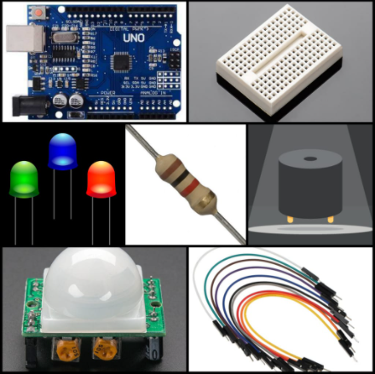

**Fig 1: Components**

ARCHITECTURE OF PIR SENSOR

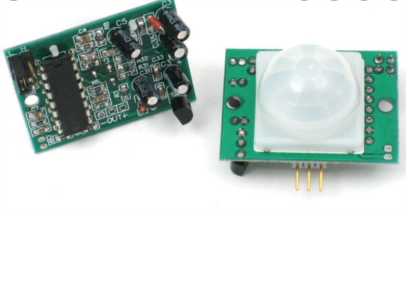

**Fig 2: PIR Sensor**

As we can see the sensor has two sides:

* Top or the Sensor Side
* Bottom or the Components Side

The Top consist of a specially designed 'High-Density Polythene' cover called "Fresnel Lens". This lens focuses the infrared rays to the underlying 'Pyroelectric Sensor'. 9.4 µMeter infrared rays can easily pass through the polyethylene cover. The sensors sensitivity range between 6 to 7 meters (20 feet) and the detection angle is 120 degrees(cone). The actual sensor is inside a sealed metal can. The can basically protects the sensor from noise, temperature and humidity.

There is a tiny window made of IR-transmissive material to allow the IR signals to reach the sensor. Behind this window are 'two' balanced PIR sensors. In idle state, both sensors detect the same amount of IR radiation. When a warm body passes by, it first intercepts one of the two sensors, causing a positive differential change between the two halves. And then, when it leaves the sensing area, the reverse happens, and the sensor generates a negative differential change. When the pulse changes or in other words the PIR sensor detects motion, the output pin changes to "digital high" or 3.3V. The bottom bit consists of a bunch of circuitries. Few of them are of our interest

Most PIR sensors have 3-pins: VCC, GND and OUT. VCC and GND are to power the module (Operating voltage: DC 5V to 20V). The OUTPUT pin is the one which communicates with the micro-controller by sending digital pulse high (3.3v) when a motion is detected and digital low (0v) when no motion is detected. The pin-outs may vary between modules so always triple-check the pin-out. The BISS0001 or the "Micro Power PIR Motion Detector IC" gets the output from the sensor and after doing some minor processing it produces the digital output. The module has two potentiometers one to adjust the sensitivity (which is up to 7m) and the other to adjust the time for which the output

signal should stay high when an object is detected (it ranges from 0.3s to 5 mins).- There are 3 more pins on this module with a jumper between them to select the trigger modes.> 1st one is called "non-repeatable trigger" - this one goes low as soon as the delay time is over.> 2nd one is called "repeatable trigger" - it stays high as long as the object is in the proximity and will turn off once the object is gone and the delay is over. I will be using this mode for this project. If you want to do a quick test before going ahead with this tutorial please follow the steps below. A testing is also a good idea to test the range and duration of sensing.

WORKING OF PIR SENSOR

Generally, **PIR sensor** can detect any living being movement in a detection range of it. PIR is made of a pyroelectric sensor, which is able to detect different levels of infrared radiation. The detector itself does not emit any energy but passively receives it.

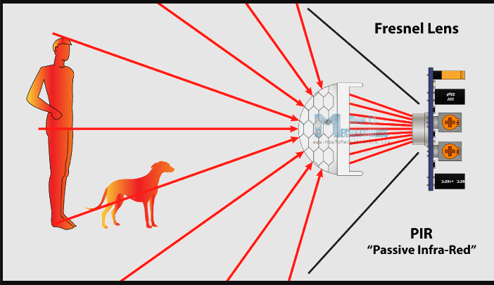

**Fig 3: Working of a PIR Sensor**

It detects infrared radiation from the environment. Once there is infrared radiation from the human boy particle with temperature, focusing on the optical system causes the pyroelectric device to generate a sudden electrical signal.

Simply, when a human body or any animal passes by, then it intercepts the first slot of PIR sensor. This causes a positive differential change between the two bisects. When a human body leaves the sensing area, the sensor generates a negative differential change between the two bisects.

# 

# METHODOLOGY

The need for home security alarm systems now-a-days is a serious demand. As the number of crimes are increasing every day, there has to be something that will keep us safe.

CONSTRUCTION**:**

So, we are going to implement a simple security system made with a help of PIR sensor and Arduino UNO board in Tinkercad platform using the following steps;

* Identify the PIR motion sensor, LED, resistor, buzzer, mini breadboard, Arduino UNO board and connecting wires.
* Connect the +5V and GND of Arduino UNO R3 to the breadboard.
* For LED: Connect the Anode (longer lead of LED) to pin 9 of Arduino and the Cathode (shorted lead of LED) to GND through 220ohm resistor as shown in the circuit diagram.
* For Buzzer: Connect the positive terminal with pin 10 of Arduino and negative terminal to GND.
* For motion sensor: connect the +VCC pin with positive, GND pin with ground terminal and sensor pin with pin 8 of Arduino UNO R3 board.

The setup is now ready. Now load the code in Arduino IDE and then upload it to Arduino. Check the serial monitor readings. Try moving the object in sensor coverage and the buzzer should ring.

# 

# 

# CIRCUIT DIAGRAM

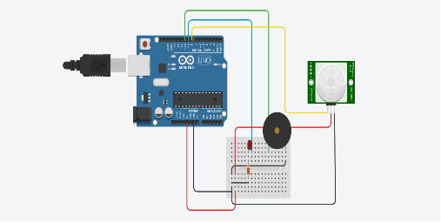

**Fig 4: Security alarm system using PIR Sensor and Arduino UNO**

WORKING OF THE CIRCUIT

When an intruder passes through the detection range of PIR sensor, it generates an electrical signal. That output of PIR motion detection sensor is **connected directly** to one of the Arduino digital pins (pin 8). If any motion is detected by the sensor, this pin value will be set to “1” and the buzzer will be activated otherwise the pin value will be set to “0”. The two potentiometers on the board allow us to adjust the sensitivity and delay time after detecting a movement.



**Fig 5: Signal when there is no Intruder found**



**Fig 6: Signal when there is an Intruder**

# 

# TEST RESULTS

# 

# 

# Fig 7: Output message

# WAVEFORM

# 

**Fig 8: Waveform**

# ADVANTAGES

1. This system is handy and portable**,** and thus can be easily carried from one place to another**.**
2. The circuitry is not that complicated and thus can be easily troubleshooted**.**
3. No separate wiring is required during installation hence no additional installation cost**.**
4. This alarm system sets off a powerful buzzer**,** and it is effective as any other alarm system available in the market**.**
5. PIR sensor consumes less power. Thus, it is less expensive.

# 

# DISADVANTAGES

1. Any kind of moving object can trigger the PIR sensor& The alarm activates only when the person cuts through the line of the PIR sensor**.**
2. The given alarm system determines the presence of the intruder only**,** and does not determine how many persons are there actually**.**
3. Passive type is insensitive to very slow motion of the object and do not operate above 35 degree Celsius.

# APPLICATIONS

1. This system can be used in museums to protect the valuable things**.**
2. Used in automatic door bell system to ring the bell when a human is detected**.**
3. Helpful in defense system to detect the humans in war field**.**
4. To protect the lockers in banks from robbery**.**
5. Used in security gates.

# FUTURE SCOPE

The paper presents one of the simple and effective alarm systems. This was achieved by the application of Arduino UNO Board and Passive Infrared Sensor as the major building blocks. In this PIR sensor-based security system, we have used low power, low cost PIR sensor that are easy to interface with other components. Currently, we have designed a security system which can set the alarm when the intruder is found. Considering all the above points, followings are our future works set to improve the system:

**a)** We can determine the position of the intruder and then send a SMS to the concerned authorities.

**b)** Work on the detection range and sensitivity of the sensor to improve security systems.

**c)** Work on the software to record videos.

# CONCLUSION

Thus**,** we have designed a home security alarm system using Arduino and PIR motion sensor**,** which is handy**,** portable**,** cost-effective and high effective as well**.** Such alarm systems are hugely in demand for security purposes**,** and thus this system can be proved useful and effective in view of the above feature

**FLOW CHART**

YES

NO

PIR =1?

Turn on buzzer and LED

Collect information from PIR Sensor